**IMPROVING ZARA’S MOBILE APPLICATION’S USER INTERFACE**

**Part 2: User study, Low fidelity prototype, and the Work-In-Progress pitch**

CPS613

Dr. Somang Nam

Chloe Parentela

Dylan Rodrigues

Ghazal Mirsayyah

Omar Syed

Shantanu Singh

March 4, 2022

**Table of Contents**

**Executive Summary**3

**Introduction**4

**User Description**4

**Data Collection**4

**Data Analysis**5

Quantitative Analysis 5

Qualitative Analysis 10

User Description 14

Use Cases 14

Looking for a specific item 14

Buying an Item/Items 16

User Persona 18

List of Requirements 19

**Low-fidelity Prototype**20

**Storyboards**22

**References**26

**Appendix**27

Data Collection Protocol 27

Consent Form 28

Data Collection Form 29

Raw Data 34

# **Executive Summary**

Zara’s mobile application has several issues. As we went through it, we noticed the carousel interfaces are hard to work with. Moreover, navigating the app is very difficult due to the placement of the buttons and the threadbare, minimalistic UI design. This and the badly organized categories for the products makes for an inconvenient usability experience. Finally, the unlabeled forms - and no indication which of them are required - cause confusion on the users’ part. To properly gauge the users’ experiences, we surveyed them using Google Forms. We then analyzed their responses to our questions, which sought to understand the users’ reaction to and their overall opinion of the Zara application. Based on this research, we have come up with a low-fidelity prototype as well as storyboards. We redesigned the whole application, focusing on UI elements such as the buttons, removing the carousels, and pages such as the homepage, the shopping cart and search results. These changes will improve the overall usability of the application and provide a more convenient, smooth functionality for the users. This will help attract new users to the application and also satisfy current ones.

# **Introduction**

For our project, the topic we will be focusing on is improving Zara’s mobile application and redesigning it to make it more usable. Firstly, the categories that Zara has organized for its products are very cumbersome, and hard to keep track of because of their large quantity. Next, the forms are unlabeled, leading to confusion on the users’ part; this is further compounded by a lack of indication about which field is required until after the user has already submitted the form. Navigation is also another major issue: going for a minimalist aesthetic, Zara has made moving through the site more involved, difficult and unintuitive. Buttons are placed in unexpected, incongruous places and are hard to distinguish due to their size and text formatting. Finally, the carousels on the application are very illegible, hard to use, and inconsistent. In order to solve these issues, we have run a survey, analyzed its data, and engaged in research and benchmarking.

# **User Description**

Based on the research that we did, the primary demographic of users for Zara are young, shop online once or twice a month, and have experience with using mobile applications. By young, we are referring to Millennials (26-40) and “Generation Z” (ages 18-25). Our secondary users would be those who are older than the specified age ranges while the tertiary users would be those who are younger than 18 years old.

# **Data Collection**

Based on the user descriptions, our target was to find young people – Generation Z or Millenial – who have some experience with mobile applications. We collected our data using Google Forms, where participants signed the consent form before proceeding with the survey. The graphs were generated in Microsoft Excel and Tableau Public for additional visualization. The link for the Google Survey is [here](https://forms.gle/fLPUKyX82n9DQUDd9). The survey consisted of three main parts; the first one, the demographics questionnaire, asked for the respondents’ gender, age, phone OS, shopping frequency, and whether they had used the Zara app before. Our next section of the questionnaire was the Systems Usability Scale (SUS) Questions, as they are a great way to gauge the usability of an application and quantify user experience and satisfaction. We used the standard 1-5 scale with 1 being “Strongly Disagree'' and 5 being “Strongly Agree”. The last section directly asks about the user’s satisfaction with certain features that we have identified to be the pain points of the application, including the design of the buttons, the layout, the sorting functionality, and so on. This also follows the Likert scale which we converted into a 1-5 point scale for a more robust analysis. The raw data can be found in the Appendix.

# **Data Analysis**

This section contains an exhaustive analysis of the data we have collected from Google Forms. We had 11 respondents from a mix of genders and age groups along with a healthy mix of seasoned and novice Zara users. Our respondents mostly used Zara’s application on iOS and the Android devices. This ensures that our data was not biased to a certain operating system. We performed both quantitative and qualitative analysis on the collected data.

## **Quantitative Analysis**

For our survey, we mainly focused on obtaining valuable data from our target demographic. Our respondents were primarily young adults from the ages of 18-23. However, in order to get some comprehensive data, we also had a few respondents aged 45 and older (Figure 1). 82% of our respondents were aged 23 and below.

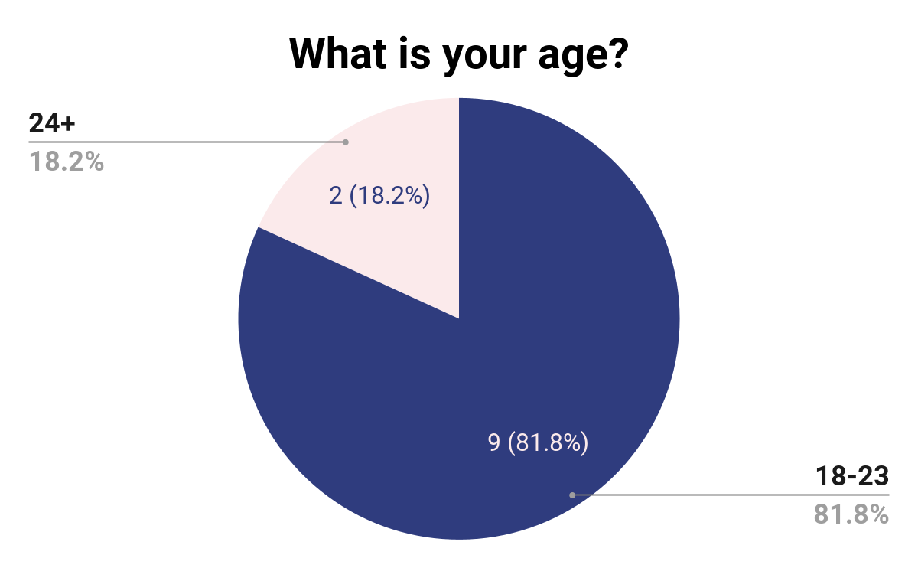

**Figure 1**: Age Distribution of our respondents

For our survey, we decided to use the System Usability Scale (SUS) in order to get a general idea of what the users thought of Zara’s user interface. The table below shows our raw data converted into scores from 1 to 5 (1 being “Strongly Disagree” and 5 “Strongly Agree”), the total SUS score as well as the median and the average scores for each question.

| **PID** | **Q1** | **Q2** | **Q3** | **Q4** | **Q5** | **Q6** | **Q7** | **Q8** | **Q9** | **Q10** | **SUS Score** |
| --- | --- | --- | --- | --- | --- | --- | --- | --- | --- | --- | --- |
| **1** | 4 | 2 | 4 | 2 | 2 | 4 | 4 | 2 | 3 | 2 | 62.5 |
| **2** | 4 | 2 | 4 | 1 | 4 | 2 | 4 | 2 | 4 | 1 | 80 |
| **3** | 2 | 4 | 4 | 2 | 2 | 1 | 3 | 4 | 2 | 2 | 50 |
| **4** | 2 | 3 | 3 | 2 | 3 | 2 | 2 | 3 | 3 | 2 | 52.5 |
| **5** | 1 | 5 | 2 | 2 | 1 | 2 | 3 | 1 | 2 | 2 | 42.5 |
| **6** | 4 | 4 | 2 | 2 | 2 | 4 | 3 | 4 | 2 | 2 | 42.5 |
| **7** | 2 | 2 | 4 | 1 | 4 | 2 | 4 | 2 | 4 | 2 | 72.5 |
| **8** | 3 | 2 | 4 | 3 | 3 | 3 | 3 | 3 | 4 | 2 | 60 |
| **9** | 4 | 2 | 4 | 1 | 4 | 3 | 5 | 2 | 4 | 2 | 77.5 |
| **10** | 1 | 5 | 2 | 1 | 4 | 5 | 3 | 5 | 2 | 3 | 32.5 |
| **11** | 3 | 3 | 2 | 2 | 2 | 4 | 3 | 3 | 2 | 3 | 42.5 |
| **AVG** | 2.72 | 3.09 | 3.18 | 1.72 | 2.81 | 2.90 | 3.36 | 2.81 | 2.90 | 2.09 | 55.909 |
| **MED** | 3 | 3 | 4 | 2 | 3 | 3 | 3 | 3 | 3 | 2 | 52.5 |

**Table 1**: Data of SUS scores

When looking at individual questions, the average of our data seems to hover between “Neutral” (3 points) to Somewhat Agree (4 points) or Disagree (2 points) depending on the questions. However, there are a few notable outliers. When asked whether they would like to use the current Zara App frequently, 65% of the respondents either remained neutral or disagreed (Figure 2). Respondents also mainly remained Neutral on whether they believed that a normal user would learn to use this system quickly. However, when asked about whether they found the app unnecessarily complex, respondents were again split on both sides but those who Agreed with the statement, agreed more strongly.

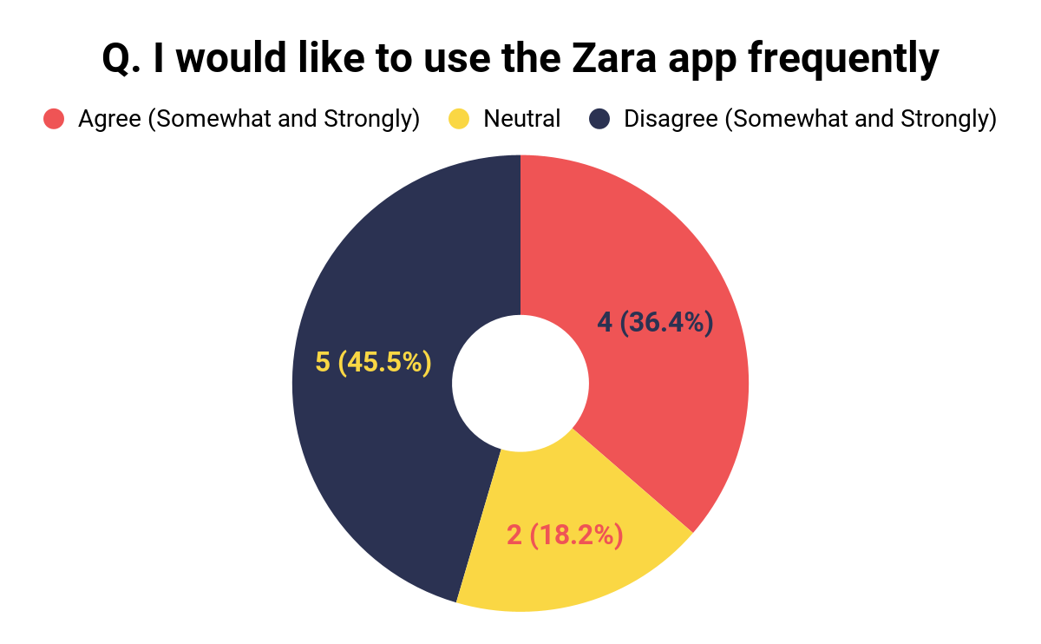

**Figure 2**: Distribution of Users who would like to use the app frequently

Analyzing by question did not lead to satisfactory results. However, looking at the Overall SUS scores, we see that most of the SUS scores were below the acceptable 68.5 limit (Figure 3) (Sauro, 2018).

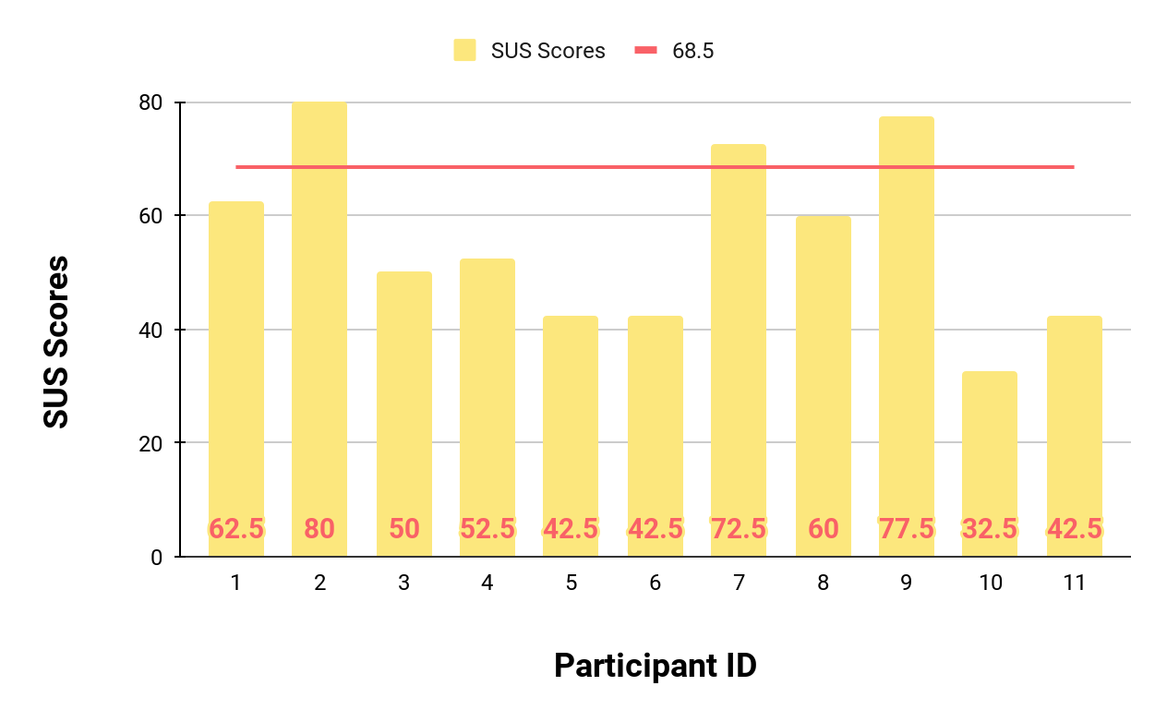

**Figure 3**: SUS Scores by Participant ID

From the graph above, it is apparent that only three out of eleven scores would be considered acceptable for meeting the Usability Standards. Therefore, according to our results, Zara’s mobile application fails to gain an acceptable score 73% of the time. This is further supported by the Average and Median SUS Scores which are 55.91 and 52.5 respectively. The Average and the Median scores are also below the 68.5 threshold indicating that the issues with the Zara App’s overall usability remains the same.

The next part of the survey aims to determine our respondents' sentiments towards our hypothesized pain points in the application. These include how intuitive interactable buttons, menu categories, search filters and carousel interfaces are on the Zara application. The survey attempts to determine which of these aspects of the Zara application are lacking, limiting user functionality and use.

| **PID** | **SQ1** | **SQ2** | **SQ3** | **SQ4** | **SQ5** | **SQ6** | **SQ7** | **SQ8** | **SQ9** | **SQ 10** | **SQ 11** | **SQ 12** | **SQ 13** | **SQ 14** | **SQ 15** | **SQ 16** |
| --- | --- | --- | --- | --- | --- | --- | --- | --- | --- | --- | --- | --- | --- | --- | --- | --- |
| **1** | 3 | 4 | 4 | 3 | 4 | 2 | 4 | 4 | 1 | 4 | 4 | 4 | 2 | 3 | 1 | 1 |
| **2** | 3 | 3 | 3 | 3 | 4 | 4 | 5 | 5 | 5 | 5 | 4 | 5 | 5 | 5 | 3 | 3 |
| **3** | 2 | 2 | 2 | 2 | 3 | 3 | 3 | 4 | 4 | 1 | 2 | 3 | 2 | 4 | 2 | 2 |
| **4** | 4 | 3 | 3 | 3 | 2 | 3 | 2 | 2 | 4 | 4 | 2 | 2 | 4 | 4 | 3 | 4 |
| **5** | 4 | 5 | 4 | 1 | 4 | 4 | 4 | 2 | 4 | 2 | 2 | 2 | 4 | 4 | 1 | 1 |
| **6** | 2 | 3 | 3 | 2 | 2 | 2 | 2 | 3 | 4 | 2 | 2 | 4 | 2 | 3 | 2 | 3 |
| **7** | 3 | 3 | 2 | 1 | 2 | 3 | 4 | 4 | 4 | 3 | 2 | 3 | 3 | 4 | 2 | 3 |
| **8** | 4 | 3 | 4 | 3 | 3 | 3 | 4 | 4 | 2 | 2 | 3 | 4 | 4 | 4 | 4 | 4 |
| **9** | 2 | 3 | 4 | 3 | 4 | 2 | 4 | 2 | 4 | 4 | 4 | 4 | 3 | 5 | 4 | 4 |
| **10** | 5 | 2 | 5 | 2 | 5 | 4 | 5 | 2 | 3 | 5 | 2 | 4 | 5 | 5 | 1 | 1 |
| **11** | 3 | 2 | 2 | 3 | 4 | 2 | 2 | 3 | 2 | 3 | 1 | 2 | 3 | 2 | 2 | 2 |
| **Mean** | 3.18 | 3 | 3.27 | 2.36 | 3.36 | 2.91 | 3.54 | 3.18 | 3.36 | 3.18 | 2.54 | 3.36 | 3.36 | 3.90 | 2.27 | 2.54 |

| **KEY** | Very Dissatisfied/ Very Difficult | Somewhat Dissatisfied/ Somewhat Difficult | Neutral/ Nor Easy or Difficult | Somewhat Satisfied/ Somewhat Easy | Very Satisfied/ Very Easy |
| --- | --- | --- | --- | --- | --- |
| **Value** | 1 | 2 | 3 | 4 | 5 |

**Table 2:** Satisfaction Questionnaire

Analyzing the satisfaction results of different functions within Zara’s application, the majority of functions performed at a neutral level, neither bad nor great, except for a few noticeable outliers. Upon deeper analysis for interactable button readability, discoverability, distinguishability and button sizes, all but one performed up to par.

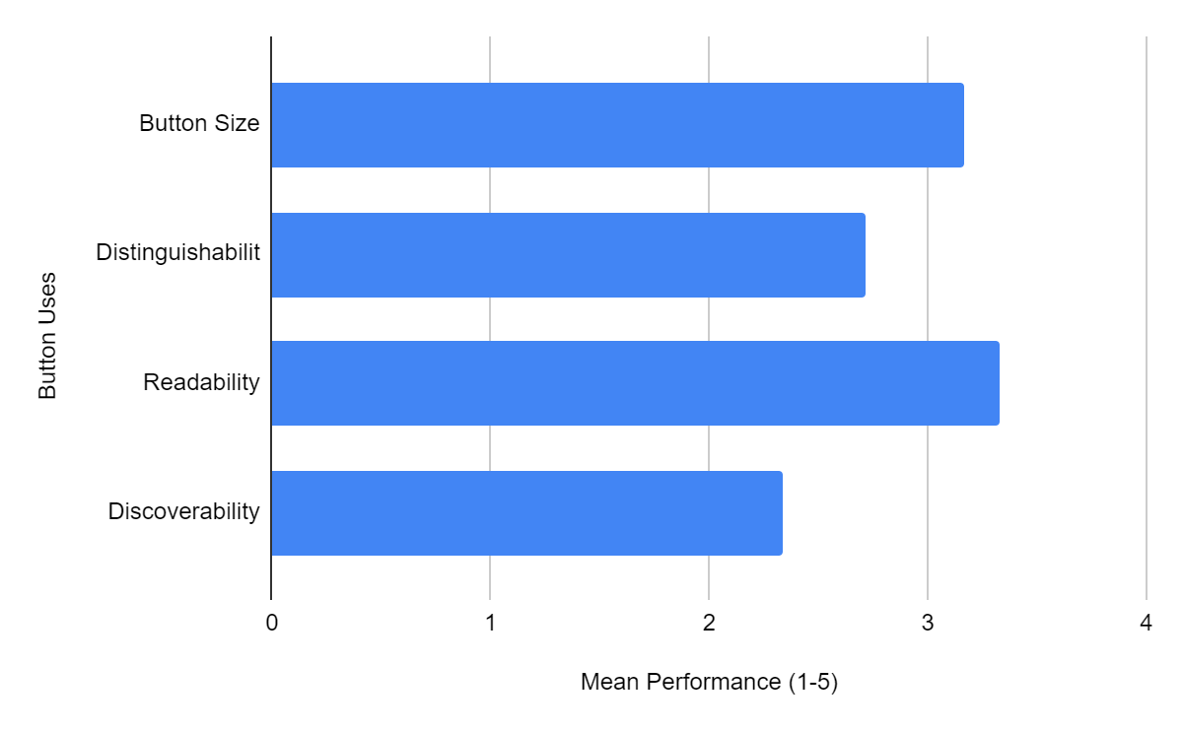

**Figure 4:** Button Characteristics’ Mean Performance Comparison



**Figure 5**

As shown above in Figure 4 and 5, button discoverability performed significantly worse than the rest of the buttons’ characteristics. Survey responses indicated that users struggled to locate specifically two button functions, the live chat and “Terms of Use” buttons (Figure 6). With a mean of approximately 2.8 from a total score of 5, the live chat button proved to be below standards and difficult to locate for many users. The “Terms of Use” button performed significantly worse than even the live chat button, with a mean of 2.27 out of 5, and approximately 73% of users indicating to have significantly struggled in locating it.

## 

**Figure 6**

## **Qualitative Analysis**

The Qualitative Analysis of our survey data yielded some interesting results. Since Zara has clothing for both men and women, we got a healthy mix of participants who shopped in these sections. 56% of our respondents identified themselves as women while the remaining 44% were men (Figure 7).

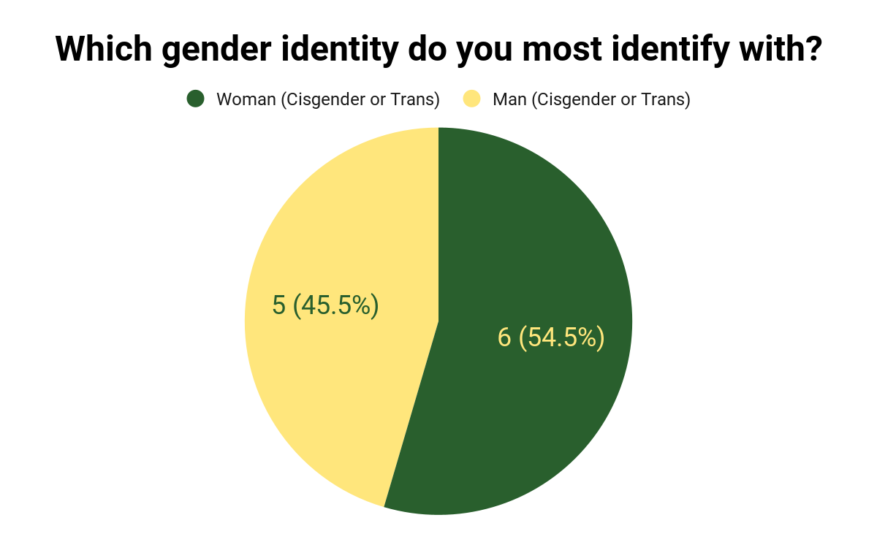

**Figure 7**: Gender Distribution of our respondents.

Our respondents mainly used Mobile Apps for their shopping. An overwhelming 90.9% of them preferred to use mobile apps when shopping online (Figure 8).

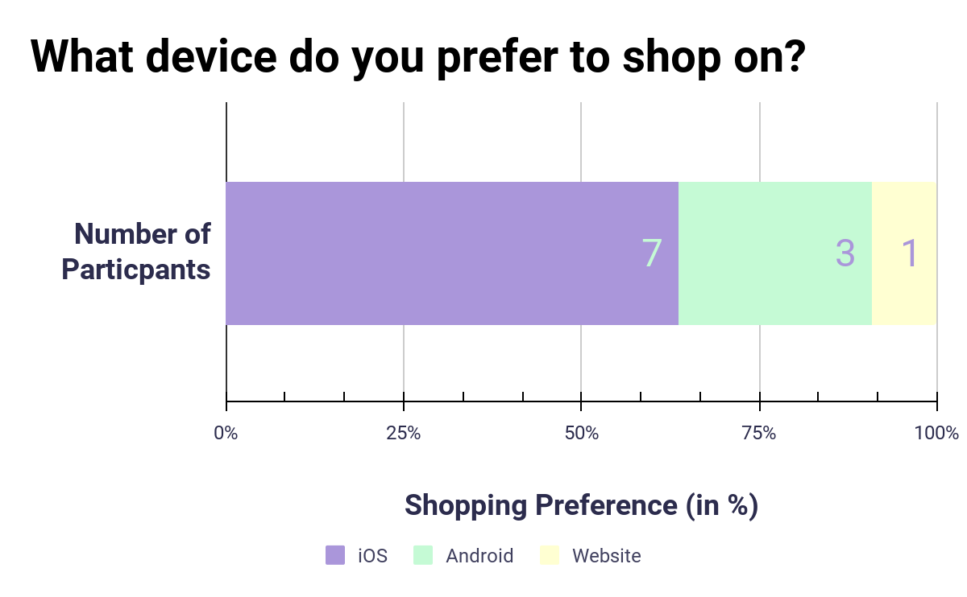

**Figure 8**: Device Distribution of our respondents.

Most of our respondents were well-versed in shopping online. 81.8% of them said that they shopped online 1-2 times a month whereas the remaining 18.2% considered themselves to be shopping often (1-2 times a week) (Figure 9). The tech-savviness of our respondents is visible as nearly half our respondents had used Zara’s mobile app before. Zara’s ubiquitous presence in the fashion industry is unmistakable as nearly half of the respondents had used the Zara App for their shopping purchases in the past (Figure 10). This also helps us build persuasive data and give accurate analysis for both Zara’s current and active users as well as the new ones.

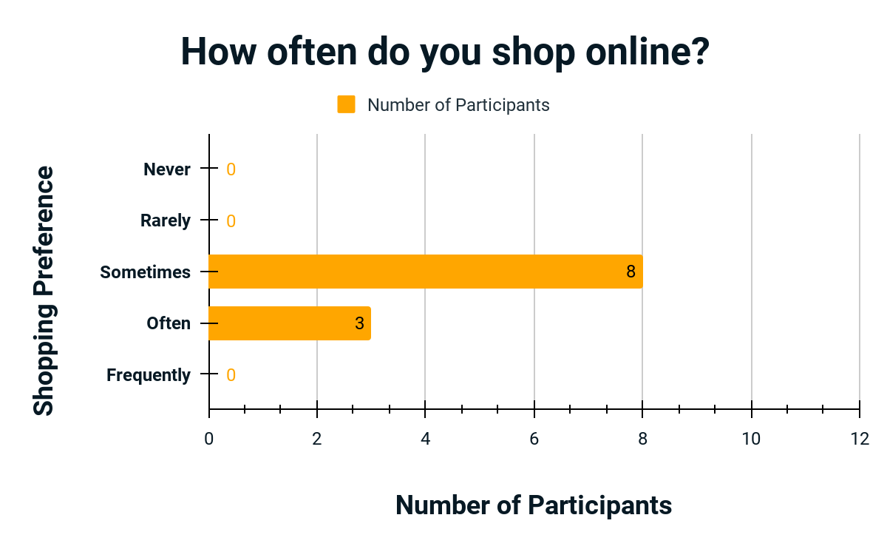

**Figure 9**: Shopping Preferences of our respondents.

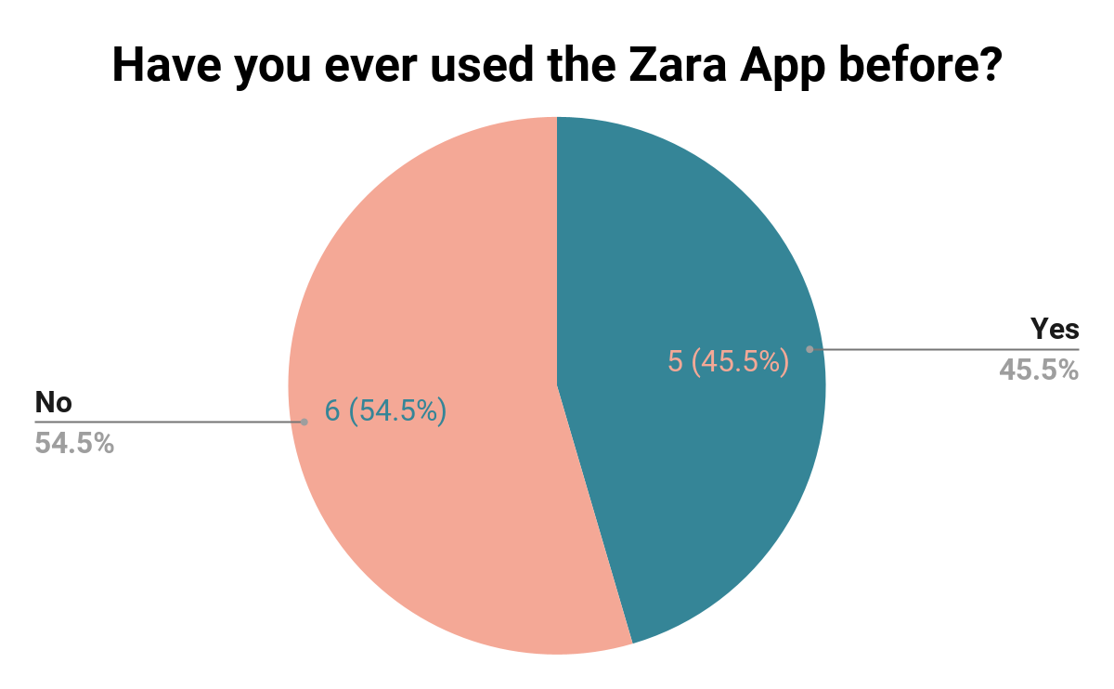

**Figure 10**: Zara App familiarity of our respondents

Most respondents to the survey were very familiar with the functionality of an online shopping application and found the majority of Zara’s mobile application to be fairly intuitive. Although responses indicated that a lot of Zara’s user interface was decently well thought out, certain points of conflict became evident.

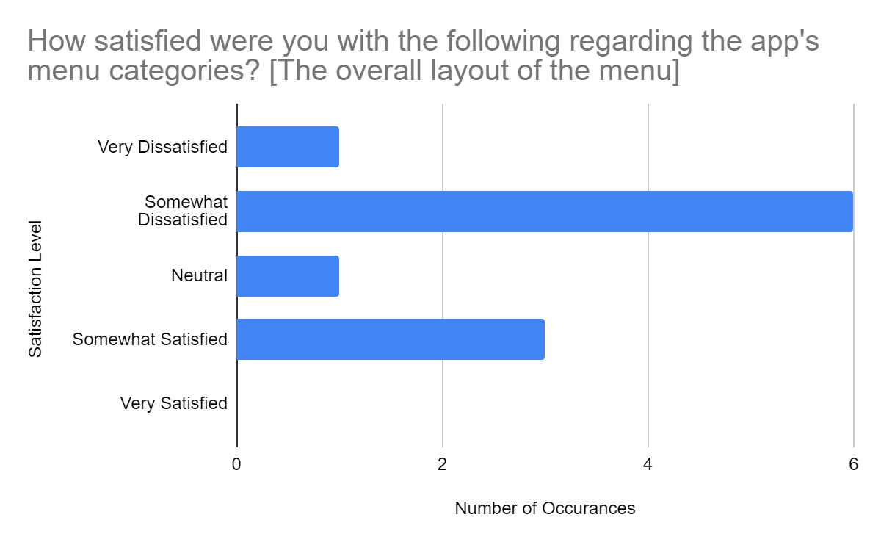

**Figure 11:** Overall Menu Layout

As shown in figure 11, the chart is skewed towards the unsatisfactory side, and none of the users found the overall menu layout very satisfactory. Majority of the respondents found the menu categories to be extremely overwhelming and counterintuitive. Even though the targeted audience proved to be experienced with tech and online shopping, the menu seemed to be confusing and over done, according to the results of our survey.



**Figure 12:** Carousel Interface

The respondents to the survey showed the most issue with the carousel interface presented to the user as the initial landing page of the Zara application. No user indicated to be “Very Satisfied” by the carousel Interface swiping mechanics and swipe indicator visibility. With a performance mean average of 2.27 and 2.54 respectively, the respondents found the structure of the carousel interface to be difficult to work with (Figure 12).

## **User Description**

After conducting the survey and collecting the data, our primary user group was confirmed to be major users of Zara. All but two from the ages 18-24 agreed that they use Zara frequently (more than twice a week) or often (once or twice a week) occasionally. The majority of them also agreed that the application was very complex but could figure it out on their own without technical help. They agreed that the buttons were too small and quite unreadable. Most were ambivalent or dissatisfied with the menu categories. The menu layout and finding the right size for them also left primary users dissatisfied with the application. They were also dissatisfied with the buttons’ sizes, legibility, and discoverability. Another major problem were the carousel interfaces used throughout the app, which the users found to be particularly confusing and cumbersome because of their inconsistency and invisibility of their swipe indicators.

Unfortunately only two older people took part in this survey. They did turn out to use Zara less frequently. They had fewer complaints with the application’s usability even though they agreed that the functionality was not well integrated, with too much inconsistency in the overall design. Both also agreed that finding the right size of clothing and using the carousel interfaces was difficult.

## **Use Cases**

### **Looking for a specific item**

| Name | Looking for a specific item |
| --- | --- |
| Description | Describes the process of a user using the mobile application to search for a specific item |
| Actor | Logged in user that is looking for a specific item. For example, Jenna. |
| Preconditions | The user is logged in. |
| Flow of Events | 1. The user uses the search icon in the navigation bar at the bottom to go to the search page 2. The user searches for an item using the text input, for example “corduroy pants” 3. The user is taken to the result page, where the items are sorted by relevance by default 4. The user may use filters to narrow down their search results 5. The user finds an item they like, and clicks on it. 6. The user is taken to that item’s information page, where they can see all the details about that item and add it to their wishlist/shopping cart. 7. The user clicks on the “Add to Cart” button. 8. The user gets a prompt that tells them the item has been added to cart successfully, and they can choose whether or not to go to checkout or continue browsing. |
| Alternative Paths | * There are no results for the user’s search, and they are prompted with related search terms that they might be interested in. * An error happens (e.g: a server error), the user is given an error message. |
| Postconditions | * Successful: The user finds the item they were looking for. * Unsuccessful: Related search terms are shown to the user - the user is given an error message |
| Scenario | Jenna searches for a new pair of jeans → Jenna needs to buy a new pair of jeans, but since she does not have enough time to buy it from a physical store, she uses Zara’s app. After opening the app, she uses the search icon from the bottom navigation bar and types in a related search item, for example, “Jeans”. Afterwards she is taken to the results page, where she uses the filters from the top right of the screen to narrow down the results, for example “Dark blue jeans between 30-80$”. Then she looks through the list, and taps on an item that she likes. She then reads the details of that item, and after selecting her desired characteristics, like “Small-sized”, she uses the “Add to cart” button to add it to her cart, and sets the quantity to her desired number. She then gets a prompt from the app, telling her the item has been successfully added to her cart, giving her the option to either continue shopping or proceed to checkout. |
| Relevant Requirements | 1. Information about the user should be stored in a database  2. Information about the items should be stored in a database  3. The application should operate on both iOS and Android devices  4. Searching for an item  5. Adding item to the cart |

### 

### **Buying an Item/Items**

| Name | Buying an item/items |
| --- | --- |
| Description | Describes the process of a user using the mobile application to checkout the item(s) in their shopping cart. |
| Actor | Logged in User with some items in their shopping cart that is trying to place an order. |
| Preconditions | The user is logged in, and already has some items in their shopping cart. |
| Flow of Events | 1. The user uses the shopping cart icon in the navigation bar at the bottom, and is taken to the shopping cart page 2. The user checks their order information. Depending on whether or not they already have their shipping information saved, the shipping information is set to default values. The user may want to edit any of this information. 3. The user is satisfied with the details, and clicks on the “Secure Checkout” page. 4. The user is taken to Zara’s payment methods’ page, where they can select their desired method of payment (e.g: Visa or PayPal) 5. The user is taken to a payment information page where they enter the required information for their selected payment method (e.g: card number). 6. When the user is done, they click on the “Complete Payment” button. 7. A confirmation screen is shown. 8. A confirmation email is sent to the user. |
| Alternative Paths | 1. The user wants to edit their order’s information. 2. The payment information is incorrect, they are asked to re-enter their information. |
| Postconditions | 1. Successful: The user completes their checkout, pays for their order, and receives a confirmation email. 2. Unsuccessful: A warning is given and they are asked to re-enter their information. |
| Scenario | Jenna places an order → Jenna already has some items in her shopping cart and is ready to place her order. She goes to her shopping cart from the bottom navigation bar, reviews the details of her order and shipping information and edits them if she wants, and then clicks on the “Secure Checkout” button. Then, she chooses her desired payment method, enters the details of her payment, and taps on the “Complete Payment” button. Everything goes well, and she is shown a confirmation page. A few seconds later, she also receives a confirmation email. |
| Relevant Requirements | 1. Information about the user should be stored in a database  2. Information about the items should be stored in a database  3. The application should operate on both iOS and Android devices  4. Editing shipping information  5. Paying for an order  6. The user should be able to perform common tasks (searching, placing orders) as fast as possible  7. The user should feel comfortable putting in personal information, like their shipping address. |

## 

## **User Persona**

The persona is a composite of the majority of our users, and based on analysis of the data collected, would be young (18-24), female and reasonably familiar with online shopping. The composite user would also be a mobile user - either Android or iOS - and not very experienced with Zara’s application. Their goals would be to find reasonably priced outfits through the ease of a mobile app. Their frustrations would involve the steep learning required to navigate and use the Zara app as well as not finding the clothes they want easily.



**Name**: Jenna Lee

**Profile**: I just want to find fashionable clothes with reasonable prices fast

**Age**: 22

**Residence**: Brampton, Ontario, Canada

**Education**: Currently studying in university

**Occupation**: Student, part-time worker

**Story:**

Jenna is a 22 year old full-time student who also works a part-time job and has very limited free time. Her tight schedule makes it difficult for her to physically go shopping, therefore she has turned to online shopping, and has downloaded her favorite brands’ applications on her phone. She uses Zara’s app once or twice a month, and has had several problems with the app’s user interface.

N**eeds**

* Easy navigation and utility
* Able to find items quickly
* Understandable layout

**Wants**

* Low learning curve for the app
* Being able to figure out the functionality easily and quickly
* Legible buttons
* move with no difficulty Ease of navigation

**Values**

* Convenient and quick service
* No bugs or lag

**Frustrations**

* Steep learning curve for the app
* Not being able to find out where everything is
* Not being able to get help
* Using the confusing carousel interfaces

## **List of Requirements**

| **Data requirements** | |
| --- | --- |
| 1. Information about the user should be stored in a database | 1. Account information (email and password) 2. Personal information (name, possibly gender and last name) 3. Shipping information (address, postal code, phone number) 4. Payment information (method of payment information, billing address) 5. Interests (e.g: green pants) |
| 2. Information about the items should be stored in a database | 1. Name, description, price, colors and sizes available, in-store availability, shipping options, and content/material/care 2. Any discounts or temporary unavailability 3. Which collection they belong to |
| **Environmental requirements** | |
| 1. The application should operate on both iOS and Android devices, as they are the most popular mobile phone operating systems and were used by 90.9% of our participants. | |
| 2. The user must have a smartphone that can connect to the internet. | |
| **Functional requirements** | |
| 1. Making an account (Sign Up) | |
| 2. Logging in to an account | |
| 3. Searching for an item | 1. Using the text field, image search, barcode search, or voice input. 2. Being able to filter the search results |
| 4. Adding item to the cart | 1. Choosing the desired characteristics (color, size, etc) 2. Adding it to the cart 3. Choosing the quantity |
| 5. Editing shipping information | |
| 6. Paying for an order | 1. Choosing a payment method 2. Entering payment information 3. Checking the information for correctness 4. Performing the transaction 5. Placing the order 6. Sending a confirmation email |
| 7. Being able to add/remove items to/from the wishlist | |
| 8. Being able to find their desired clothing category from the menu | |
| **Usability requirements** | |
| As explained in the user description through data analysis, the primary users of the app are young and mostly online shop at least once or twice a month, and want to be able to shop fastly. | |
| **User Experience requirements** | |
| 1. The app should be easy to use and navigate. | |
| 2. The user should be able to find help as easily as possible. | |
| 3. The user should be able to perform common tasks (searching, placing orders) as fast as possible. | |
| 4. The app should look easy on the eyes. | |
| 5. The user should feel comfortable putting in personal information, like their shipping address. | |

# **Low-fidelity Prototype**

The link to the prototype: <https://www.figma.com/file/npCWEZato3i6FDwFSETn4r/CPS-613?node-id=0%3A1>

**Remote Prototype Testing Instructions:**

1. Use the link above to open the Figma project for the prototype.
2. Use the ▷ icon on the top-right corner of the screen to run the prototype in a new tab (Figure 13).

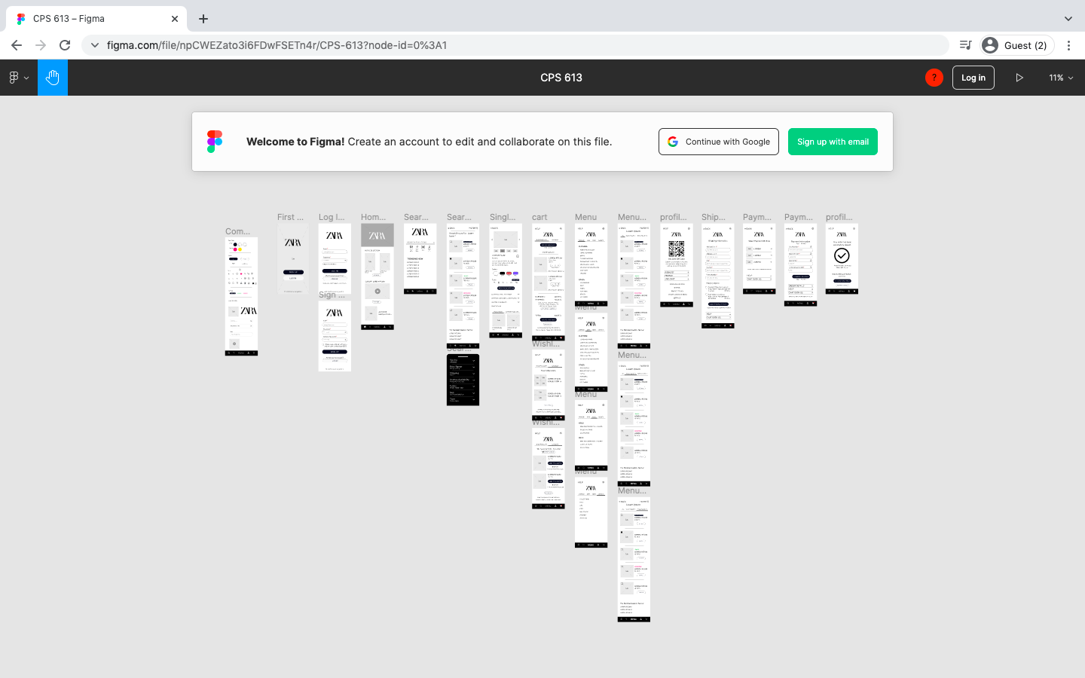

**Figure 13**: Running the Prototype

1. The prototype will open in a new tab as shown in Figure 14.

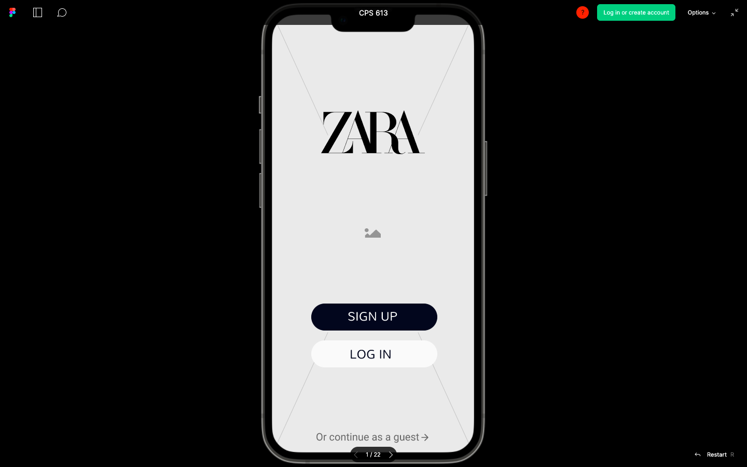

**Figure 14**: The Running Prototype

1. The running prototype can be used like an actual application. Click on the buttons and scroll through the pages.

# **Storyboards**

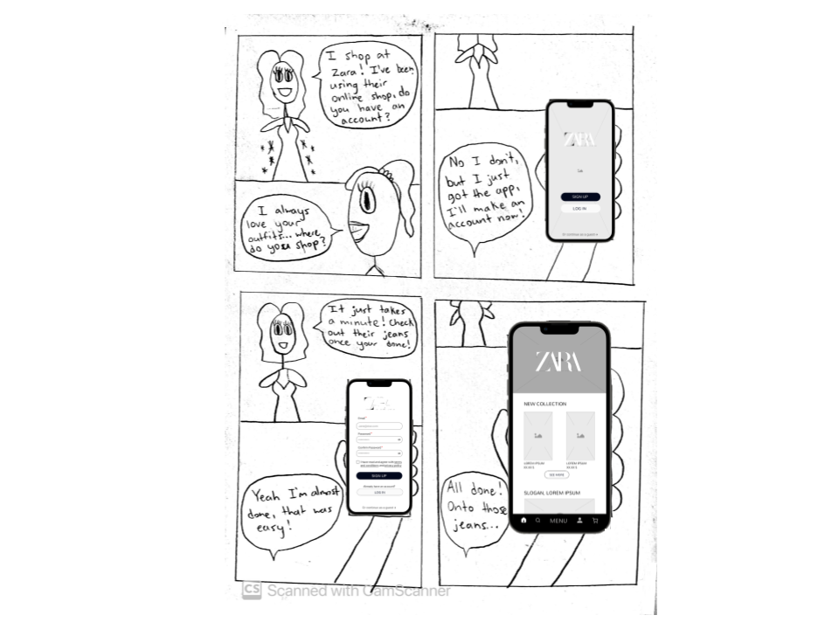

**Storyboard #1:** User makes a profile using the sign-up page.

The user is curious about where their friend gets their clothes from, and ends up downloading the Zara app. The user is first prompted with the landing page, which allows them to either log in, create an account, or continue as a guest, and the user clicks the most prominent button to sign-up. After doing so, the user is prompted with the homepage.



**Storyboard #2:** User finds a product using the filter.

The user finds a pair of pants in-person at the Zara store, however they don’t carry their size. A Zara employee reminds them that they may find the product in their size online on the Zara app. The user follows the menu to the Jeans and Pants category, and the employee reminds them that they could use the filter feature to find the product quickly. The user refines their search by filtering by type, specifically for mom jeans. They are prompted with the results page, where they quickly find the product in their size.

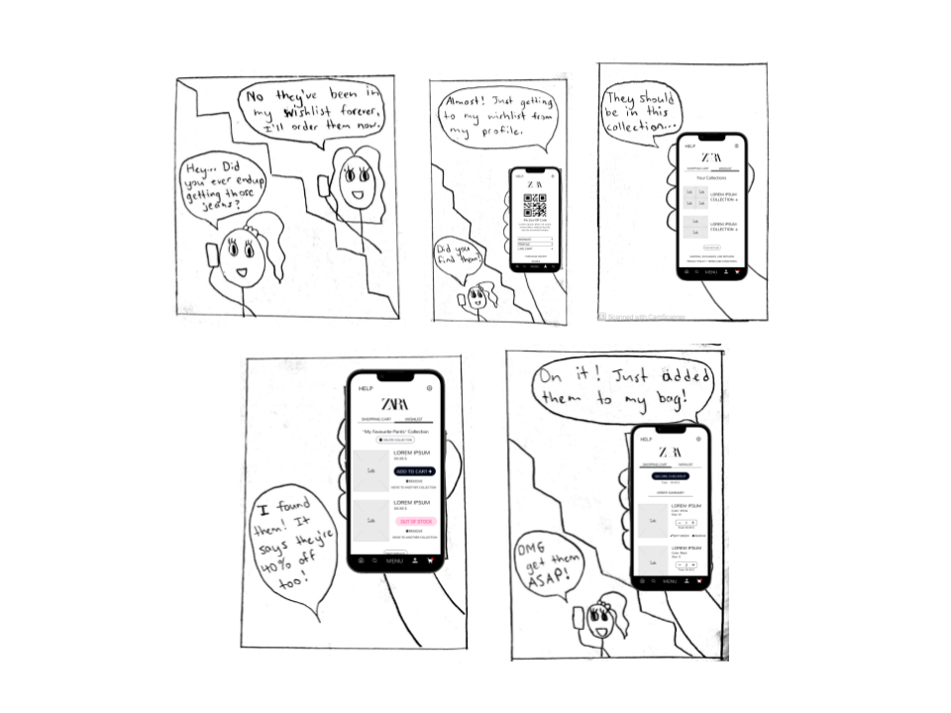

**Storyboard #3:** User adds an item from their wishlist to their cart.

The user’s friend reminds them about the jeans that have been sitting in their wishlist for a while, and the user decides to finally purchase them. The user finds their wishlist from their profile, and finds the jeans within the results listed. From there, the user clicks the product and clicks to add them to their shopping cart.

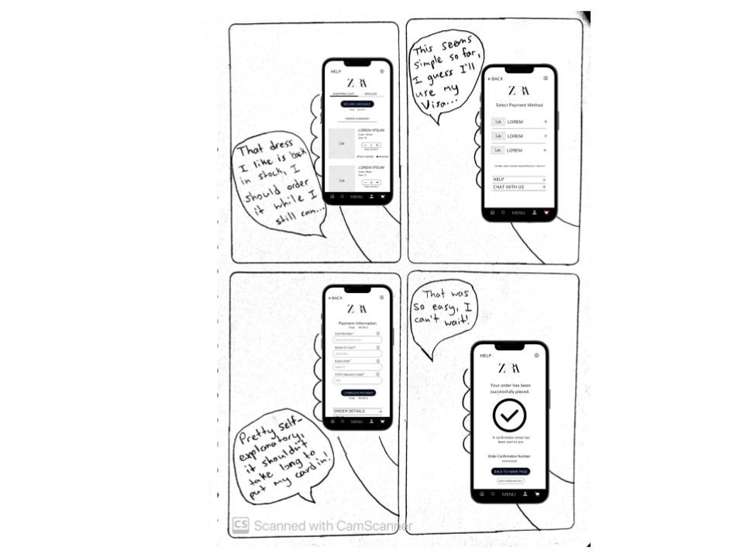

**Storyboard #4:** User completes a purchase.

The user views their shopping bag, and decides to check out. They click “Secure Checkout” which leads them to selecting a payment method. After clicking a payment method, the user is prompted to enter their card details. Upon completion, the user is shown a page that confirms their order, and then allows them to either view order details or return to the homepage.

# **References**

Sauro, J. (2018, September 19). *5 Ways To Interpret A Sus Score*. MeasuringU. <https://measuringu.com/interpret-sus-score/>

# **Appendix**

## Data Collection Protocol

1. **Project Title:** Improving Zara’s Mobile Application’s User Interface
2. **Investigators:** Chloe Parentela, Dylan Rodrigues, Ghazal Mirsayyah, Omar Syed, and Shantanu Singh
3. **Purpose:** The purpose of our study is to gain insight into the minds of the typical users of Zara’s mobile application. We intend to understand the aspects of Zara’s user interface that present the most issues and how they can be improved.
4. **Process to be followed:** We will explain to our study participants the purpose of this study, and have them sign a consent form. We will then ask the participants to take some time to interact with the Zara mobile application, testing as many functions as they can. Once the user has familiarized themself with the application, we will give the participants access to the survey to fill out while also having the Zara application running next to them if they need to refer back to it. All concerns and noticeable issues will then be recorded in the survey data.
5. **Participant Selection:** Participants are generally chosen by their age groups, with our ideal target between the ages of 18-23 as well as some users outside the age range for a more rounded data set.
6. **Relationships:** Our relationship with the participants are not restrictive. As long as the participants are willing to follow the instructions and are able to provide important data, the relationship between us and the participants does not play a significant role.
7. **Risk and Benefit:** There is minimal to no risk for our respondents when participating in our study. Only thing required from the participants is some time and focus for best results. The benefits would be that participant data would provide us a better understanding of the possible issues in the user interface and how we can plan to improve on them. Participants are free to withdraw from the study at any time without the need to provide any explanation.
8. **Consent Details:** We intend to explain to all participants the purpose of the study and the logistics of the attached consent form to them. The process of the study will only continue if the participants agree with the consent form and sign it digitally.
9. **Compensations:** There is no compensation for the participants within this study.
10. **Information Sought:** The information sought is present in the survey which will be conducted at the participants own time.
11. **Confidentiality:** All information provided by the participants will be kept confidential by the investigators. Aside from the purposes of this study, the only other use of all information provided will be for the submission of the assignment, which will make it accessible by our professor as well as his TAs.

## Consent Form

**Improving Zara’s Mobile Application’s User Interface**

I hereby consent to participate in a study conducted by Chloe Parentela, Dylan Rodrigues, Ghazal Mirsayyah, Omar Syed, and Shantanu Singh for an assignment in Ryerson University’s CPS 613 course, Human-Computer Interaction.

I agree to participate in this study, the purpose of which is evaluating Zara's mobile application from the users' perspective.

I understand that:

1. The procedures to be used are answering a few demographic questions, using different functionalities of the application, and filling out a questionnaire about them.
2. I will receive no compensation for my participation.
3. I am free to withdraw before or at any time during the study without the need to give any explanation.
4. All materials and results will be kept confidential, and, in particular, my name and any identifying or identified information will not be associated with the data.

**Participant**

| What is your name? |  |
| --- | --- |
| Please read the above conditions and sign your initials if you consent to them. |  |
| Today’s Date |  |



**Investigators**

| **Name** | **Signature/Initials** |
| --- | --- |
| Chloe Parentela | C.P. |
| Dylan Rodrigues | D.R. |
| Ghazal Mirsayyah | G.M. |
| Omar Syed | O.S. |
| Shantanu Singh | S.S. |

## Data Collection Form

| **Demographic Questions** | |
| --- | --- |
| 1. Which gender identity do you most identify with? | * Woman (Cisgender or Trans) * Man (Cisgender or Trans) * Non-binary (Any of the subgroups) * Two-Spirit * Other - Please indicate: _______ * Prefer not to say |
| 2. What is your age? | * 18 and under * 18 - 23 * 24-29 * 30-35 * 35-40 * 40+, please indicate: _______ |
| 3. How often do you shop online? | * Never (0-2 times a year) * Rarely (1-2 times every season) * Sometimes (1-2 times a month) * Often (1-2 times a week) * Frequently (more than twice a week) |
| 4. Have you ever used Zara’s app before? | * Yes * No * I don’t remember |
| 5. What type of device do you use the most for the app? | * Android * iOS * Other: ________ |
| 7. Do you have any accessibility requirements? If yes, what is it? (optional) |  |

| **SUS Questions** |
| --- |
| **Rate your level of agreement the following statements regarding Zara's mobile application:**   |  | Strongly Disagree | Disagree | Neutral | Agree | Strongly Agree | | --- | --- | --- | --- | --- | --- | | 1) I think that I would like to use this system frequently. |  |  |  |  |  | | 2) I found the system unnecessarily complex. |  |  |  |  |  | | 3) I thought the system was easy to use. |  |  |  |  |  | | 4) I think that I would need the support of a technical person to be able to use this system. |  |  |  |  |  | | 5) I found the various functions in this system were well integrated. |  |  |  |  |  | | 6) I thought there was too much inconsistency in this system. |  |  |  |  |  | | 7) I would imagine that most people would learn to use this system very quickly. |  |  |  |  |  | | 8) I found the system very cumbersome to use. |  |  |  |  |  | | 9) I felt very confident using the system. |  |  |  |  |  | | 10) I needed to learn a lot of things before I could get going with this system. |  |  |  |  |  | |

| **UI Elements Questions** |
| --- |
| **1. How satisfied were you with the following regarding the app's buttons?**   |  | Very Dissatisfied | Somewhat Dissatisfied | Neutral | Somewhat Satisfied | Very Satisfied | | --- | --- | --- | --- | --- | --- | | Size of the buttons |  |  |  |  |  | | Distinguishability |  |  |  |  |  | | Readability |  |  |  |  |  | | Discoverability |  |  |  |  |  | |
| **2. How easy was finding the following buttons?**   |  | Very Easy | Somewhat Easy | Nor Easy or Difficult | Somewhat Difficult | Very Difficult | | --- | --- | --- | --- | --- | --- | | The “Help” button |  |  |  |  |  | | The “Settings” button |  |  |  |  |  | | The “Live Chat” button |  |  |  |  |  | | The “Privacy Policy” and “Terms of Use” buttons |  |  |  |  |  | |
| **3. How satisfied were you with the following regarding the app's menu categories?**   |  | Very Dissatisfied | Somewhat Dissatisfied | Neutral | Somewhat Satisfied | Very Satisfied | | --- | --- | --- | --- | --- | --- | | Number of items |  |  |  |  |  | | Font size |  |  |  |  |  | | Division of general categories (Men, Women, Kids, Beauty) |  |  |  |  |  | | Sorting clothes by different criteria |  |  |  |  |  | | Figuring out your size for Zara |  |  |  |  |  | | Finding your size |  |  |  |  |  | | The overall layout of the menu |  |  |  |  |  | |
| **4. How easy were the following operations?**   |  | Very Easy | Somewhat Easy | Nor Easy or Difficult | Somewhat Difficult | Very Difficult | | --- | --- | --- | --- | --- | --- | | Finding clothing items |  |  |  |  |  | | Searching for items |  |  |  |  |  | | Filtering search |  |  |  |  |  | |
| **5. How satisfied were you with the following regarding the app's carousel interfaces?**   |  | Very Dissatisfied | Somewhat Dissatisfied | Neutral | Somewhat Satisfied | Very Satisfied | | --- | --- | --- | --- | --- | --- | | Swiping through the content |  |  |  |  |  | | The swipe indicator’s visibility |  |  |  |  |  | |

## Raw Data

**Demographic questions**:

| **Person** | **Date** | **Which gender identity do you most identify with?** | **What is your age?** | **How often do you shop online?** | **Have you ever used Zara’s app before?** | **What type of device do you use the most for shopping apps?** | **Do you have any accessibility requirements? If yes, please indicate. (optional)** |
| --- | --- | --- | --- | --- | --- | --- | --- |
| P1 | 2/22/2022 | Woman (Cisgender or Trans) | 45 | Sometimes (1-2 times a month) | Yes | iOS | N/A |
| P2 | 2/22/0022 | Woman (Cisgender or Trans) | 18 - 23 | Sometimes (1-2 times a month) | Yes | iOS |  |
| P3 | 2/23/2022 | Woman (Cisgender or Trans) | 18 - 23 | Sometimes (1-2 times a month) | Yes | iOS | The app is tough to figure out if you're a first time user. If you’re a repeated customer, still the app is pretty messed up as it’s hard to navigate and search categories in. |
| P4 | 2/23/2022 | Woman (Cisgender or Trans) | 18 - 23 | Sometimes (1-2 times a month) | Yes | iOS |  |
| P5 | 2/22/2022 | Woman (Cisgender or Trans) | 18 - 23 | Sometimes (1-2 times a month) | No | (Personal Computer) Online shopping by website or by in-person shopping |  |
| P6 | 2/23/2022 | Woman (Cisgender or Trans) | 18 - 23 | Often (1-2 times a week) | No | iOS |  |
| P7 | 8/8/2000 | Man (Cisgender or Trans) | 18 - 23 | Often (1-2 times a week) | Yes | Android |  |
| P8 | 2/23/2022 | Man (Cisgender or Trans) | 18 - 23 | Sometimes (1-2 times a month) | No | iOS |  |
| P9 | 2/23/2022 | Man (Cisgender or Trans) | 18 - 23 | Sometimes (1-2 times a month) | No | iOS |  |
| P10 | 2/24/2022 | Man (Cisgender or Trans) | 18 - 23 | Sometimes (1-2 times a month) | No | Android |  |
| P11 | 2/24/2022 | Man (Cisgender or Trans) | 66 | Sometimes (1-2 times a month) | No | Android | Limited Vision |

**SUS questions**:

| **Person** | **Q1** | **Q2** | **Q3** | **Q4** | **Q5** | **Q6** | **Q7** | **Q8** | **Q9** | **Q10** |
| --- | --- | --- | --- | --- | --- | --- | --- | --- | --- | --- |
| P1 | Agree | Disagree | Agree | Disagree | Disagree | Agree | Agree | Disagree | Neutral | Disagree |
| P2 | Agree | Disagree | Agree | Strongly Disagree | Agree | Disagree | Agree | Disagree | Agree | Strongly Disagree |
| P3 | Disagree | Agree | Agree | Disagree | Disagree | Strongly Disagree | Neutral | Agree | Disagree | Disagree |
| P4 | Disagree | Neutral | Neutral | Disagree | Neutral | Disagree | Disagree | Neutral | Neutral | Disagree |
| P5 | Strongly Disagree | Strongly Agree | Disagree | Disagree | Strongly Disagree | Disagree | Neutral | Strongly Disagree | Disagree | Disagree |
| P6 | Agree | Agree | Disagree | Disagree | Disagree | Agree | Neutral | Agree | Disagree | Disagree |
| P7 | Disagree | Disagree | Agree | Strongly Disagree | Agree | Disagree | Agree | Disagree | Agree | Disagree |
| P8 | Neutral | Disagree | Agree | Neutral | Neutral | Neutral | Neutral | Neutral | Agree | Disagree |
| P9 | Agree | Disagree | Agree | Strongly Disagree | Agree | Neutral | Strongly Agree | Disagree | Agree | Disagree |
| P10 | Strongly Disagree | Strongly Agree | Disagree | Strongly Disagree | Agree | Strongly Agree | Neutral | Strongly Agree | Disagree | Neutral |
| P11 | Neutral | Neutral | Disagree | Disagree | Disagree | Agree | Neutral | Neutral | Disagree | Neutral |

**Button Usability Questions:**

How satisfied were you with the following regarding the app's buttons?

| **Person** | **Size of the buttons** | **Distinguishability** | **Readability** | **Discoverability** |
| --- | --- | --- | --- | --- |
| P1 | Neutral | Somewhat Satisfied | Somewhat Satisfied | Neutral |
| P2 | Neutral | Neutral | Neutral | Neutral |
| P3 | Somewhat Dissatisfied | Somewhat Dissatisfied | Somewhat Dissatisfied | Somewhat Dissatisfied |
| P4 | Somewhat Satisfied | Neutral | Neutral | Neutral |
| P5 | Somewhat Satisfied | Very Satisfied | Somewhat Satisfied | Very Dissatisfied |
| P6 | Somewhat Dissatisfied | Neutral | Neutral | Somewhat Dissatisfied |
| P7 | Neutral | Neutral | Somewhat Dissatisfied | Very Dissatisfied |
| P8 | Somewhat Satisfied | Neutral | Somewhat Satisfied | Neutral |
| P9 | Somewhat Dissatisfied | Neutral | Somewhat Satisfied | Neutral |
| P10 | Very Satisfied | Somewhat Dissatisfied | Very Satisfied | Somewhat Dissatisfied |
| P11 | Neutral | Somewhat Dissatisfied | Somewhat Dissatisfied | Neutral |

**Button Discoverability Questions:**

How easy was finding the following buttons?

| **Person** | **The “Help” button** | **The “Settings” button** | **The “Live Chat” button** | **The “Privacy Policy” and “Terms of Use” button** |
| --- | --- | --- | --- | --- |
| P1 | Nor Easy or Difficult | Somewhat Difficult | Somewhat Difficult | Difficult |
| P2 | Somewhat easy | Somewhat easy | Nor Easy or Difficult | Somewhat Difficult |
| P3 | Nor Easy or Difficult | Nor Easy or Difficult | Nor Easy or Difficult | Somewhat easy |
| P4 | Nor Easy or Difficult | Somewhat easy | Somewhat easy | Somewhat Difficult |
| P5 | Somewhat easy | Somewhat easy | Somewhat easy | Somewhat easy |
| P6 | Somewhat easy | Nor Easy or Difficult | Nor Easy or Difficult | Nor Easy or Difficult |
| P7 | Somewhat Difficult | Somewhat Difficult | Nor Easy or Difficult | Somewhat Difficult |
| P8 | Somewhat Difficult | Somewhat Difficult | Somewhat Difficult | Somewhat Difficult |
| P9 | Somewhat easy | Somewhat easy | Nor Easy or Difficult | Very Difficult |
| P10 | Somewhat easy | Somewhat easy | Nor Easy or Difficult | Somewhat Difficult |
| P11 | Somewhat Difficult | Nor Easy or Difficult | Very Difficult | Very Difficult |

**Menu Categories’ Questions:**

How satisfied were you with the following regarding the app's menu categories?

| **Person** | **Number of items** | **Font size** | **Division of general categories (Men, Women, Kids, Beauty)** | **Sorting clothes by different criteria** | **Figuring out your size for Zara** | **Finding your size** | **The overall layout of the menu** |
| --- | --- | --- | --- | --- | --- | --- | --- |
| P1 | Somewhat Satisfied | Somewhat Dissatisfied | Satisfied | Somewhat Satisfied | Very Dissatisfied | Somewhat Satisfied | Somewhat Satisfied |
| P2 | Somewhat Satisfied | Somewhat Satisfied | Very Satisfied | Very Satisfied | Very Satisfied | Very Satisfied | Somewhat Satisfied |
| P3 | Neutral | Neutral | Neutral | Somewhat Satisfied | Somewhat Satisfied | Very Dissatisfied | Somewhat Dissatisfied |
| P4 | Somewhat Dissatisfied | Neutral | Somewhat Dissatisfied | Somewhat Dissatisfied | Somewhat Satisfied | Somewhat Satisfied | Somewhat Dissatisfied |
| P5 | Somewhat Satisfied | Somewhat Satisfied | Somewhat Satisfied | Somewhat Dissatisfied | Somewhat Satisfied | Somewhat Dissatisfied | Somewhat Dissatisfied |
| P6 | Somewhat Dissatisfied | Somewhat Dissatisfied | Somewhat Dissatisfied | Neutral | Somewhat Satisfied | Somewhat Dissatisfied | Somewhat Dissatisfied |
| P7 | Somewhat Dissatisfied | Neutral | Somewhat Satisfied | Somewhat Satisfied | Somewhat Satisfied | Neutral | Somewhat Dissatisfied |
| P8 | Neutral | Neutral | Somewhat Satisfied | Somewhat Satisfied | Somewhat Dissatisfied | Somewhat Dissatisfied | Neutral |
| P9 | Somewhat Satisfied | Somewhat Dissatisfied | Somewhat Satisfied | Somewhat Dissatisfied | Somewhat Satisfied | Somewhat Satisfied | Somewhat Satisfied |
| P10 | Very Satisfied | Somewhat Satisfied | Very Satisfied | Somewhat Dissatisfied | Neutral | Very Satisfied | Somewhat Dissatisfied |
| P11 | Somewhat Satisfied | Somewhat Dissatisfied | Somewhat Dissatisfied | Neutral | Somewhat Dissatisfied | Neutral | Very Dissatisfied |

**Ease of Use Questions**:

How easy were the following operations?

| **Person** | **Finding clothing items** | **Searching for items** | **Filtering search** |
| --- | --- | --- | --- |
| P1 | Somewhat easy | Somewhat Difficult | Nor Easy or Difficult |
| P2 | Very easy | Very easy | Very easy |
| P3 | Nor Easy or Difficult | Somewhat Difficult | Somewhat easy |
| P4 | Somewhat Difficult | Somewhat easy | Somewhat easy |
| P5 | Somewhat Difficult | Somewhat easy | Somewhat easy |
| P6 | Somewhat easy | Somewhat Difficult | Nor Easy or Difficult |
| P7 | Nor Easy or Difficult | Nor Easy or Difficult | Somewhat easy |
| P8 | Somewhat easy | Somewhat easy | Somewhat easy |
| P9 | Somewhat easy | Nor Easy or Difficult | Very easy |
| P10 | Somewhat easy | Very easy | Very easy |
| P11 | Somewhat Difficult | Nor Easy or Difficult | Somewhat Difficult |

**Carousel Interfaces’ Questions**:

How satisfied were you with the following regarding the app's carousel interfaces?

| **Person** | **Swiping through the content** | **The swipe indicator’s visibility** |
| --- | --- | --- |
| P1 | Very Dissatisfied | Very Dissatisfied |
| P2 | Neutral | Neutral |
| P3 | Somewhat Dissatisfied | Somewhat Dissatisfied |
| P4 | Neutral | Somewhat Satisfied |
| P5 | Very Dissatisfied | Very Dissatisfied |
| P6 | Somewhat Dissatisfied | Neutral |
| P7 | Somewhat Dissatisfied | Neutral |
| P8 | Somewhat Satisfied | Somewhat Satisfied |
| P9 | Somewhat Satisfied | Somewhat Satisfied |
| P10 | Very Dissatisfied | Very Dissatisfied |
| P11 | Somewhat Dissatisfied | Somewhat Dissatisfied |